|  |  |  |  |
| --- | --- | --- | --- |
| \\lyng-dc1\StaffShared\Learning Bugs Animals ALL subjects\characters bugs animals\Cyril the Snail - History.jpeg**Lyng Primary School Knowledge Organiser** | | | |
| **History Topic:** | What Was Anglo-Saxon Society Like? | Year 4  *Battles, Beliefs and Buildings* | Autumn |

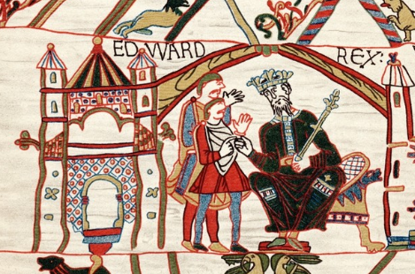

|  |  |
| --- | --- |
| **What Step On and Goldilocks words will I use?** | |
| **Spelling** | **Definition** |
| Angles | people from Germany who invaded Britain around AD 410 |
| Anglo-Saxon | the name given to the people who travelled from Germany and South Denmark and settled in Britain around AD 410 |
| archaeologist | someone who studies the past by exploring old remains |
| artefact | an object from the past that shows evidence of what life was like |
| century | a period of 100 years |
| Christianity | the region based on the teachings of Jesus Christ |
| invasion | to try and take over a place by force |
| Jutes | people from the Jutland peninsula (Germany and Southern Denmark) who invaded Britain around AD 410 |
| migration | movement from one place to another in order to settle there |
| Monk | a member of a male religious community |
| Picts | ancient tribes who lived in northern Scotland |
| pagan | a person who follows a religion that is not a major religion, including Christianity, Islam, Judaism, Buddhism, Hinduism, and Sikhism |
| Saxons | people from northern and central Germany who invaded Britain around AD 410 |
| Scots | people from Ireland who eventually settled in Scotland |
| settler/ settlement | people who migrate to a new place. When people start a community, this is a settlement |

|  |  |
| --- | --- |
| **When? (Timeline of key events)** | |
| 410 | Romans left Britain leaving it unguarded by armies and open to invasion by others. |
| 455 | The Kingdom of Kent was formed |
| 477 | The kingdom of Sussex was formed. |
| 527 | The kingdom of Essex was formed. |
| 575 | The kingdom of East Anglia was formed. |
| 586 | The kingdom of Mercia was formed. |
| 597 | St Augustine came to England and introduced people to Christianty. |
| 757 - 796 | Offa was the king of the kingdom of Mercia and declared himself King of England. |
| 802 | Egbert was the first Anglo-Saxon king of all England. |
| 871 - 899 | Alfred the Great ruled |
| 1016 - 1035 | Canute the Great ruled as the first Viking king. |
| 1066 | The Battle of Hastings took place resulting in the Normans defeating the Anglo Saxons. |

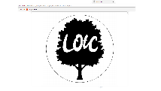

**Hook**

**Magnus’ mystery**

Discovering Anglo-Saxon artefacts and a letter from Magnus (character from key text) found in the forest, asking children to design and create an Anglo- Saxon shield.

*Viking Man

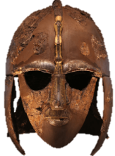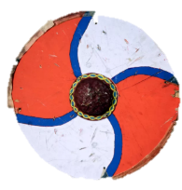

**TRIP/ VISITOR**

**Anglo-Saxon Man**

**Tamworth Castle-**

Experience archaeological Anglo-Saxon findings and meet a Saxon soldier where they will learn about the Saxon hierarchy.

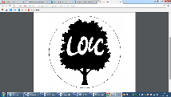

**Charles Darwin** – “It is not the strongest of the species that survives, not the most intelligent that survives, It is the one that is the most adaptable to change.

**Great Quotes**

**Our Storytelling Approach to enhance engagement**

|  |  |  |
| --- | --- | --- |
| **People:**  Anglo-Saxon War-Chiefs. ‘Bretwalda’ ruler of all the Kingdom. | **Place:**  East Anglia, Senlac Hill (Battle of Hastings) | **Problem:**  Should we go to battle? Who should rule? |

**Key Facts and Famous Figures**

**Focus Text**

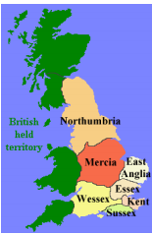

The Anglo-Saxons came to England after the Romans left in the year 410. Nobody was really ruling all of England at the time – there were a lot of little kingdoms ruled by Anglo-Saxons that eventually came together as one country.

The earliest English kings were Anglo-Saxons, starting with Egbert in the year 802. Anglo-Saxons ruled for about three centuries, and during this time they formed the basis for the English monarchy and laws. The two most famous Anglo-Saxon kings are Alfred the Great and Canute the Great.

The Anglo-Saxons are made up of three tribes who came to England from across the North Sea around the middle of the 5th century – the Angles, Saxons and Jutes.

Egbert was the first Anglo-Saxon king to rule England. The last Anglo-Saxon king was Harold II in 1066.

The Anglo-Saxon period covers about 600 years, and Anglo-Saxon kings ruled England for about 300 years.

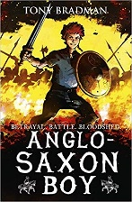

**Key skills – Taken from Milestone 2 – Sequence of Learning**

* I can use evidence to ask questions and find answers about the past.
* Use more than one source of evidence for historical enquiry in order to gain a more accurate understanding of history.
* I can describe the characteristic features of the past, including ideas, beliefs, attitudes and experiences of men, women and children.
* I can use dates and terms to describe events.
* I can use appropriate historical vocabulary to communicate
* I can use literacy, numeracy and computing skills to a good standard in order to communicate information about the past.

**Agreed Outcome**

To understand the events leading up to and during the Battle of Hastings.

|  |  |  |  |
| --- | --- | --- | --- |
| \\lyng-dc1\StaffShared\Learning Bugs Animals ALL subjects\characters bugs animals\Cyril the Snail - History.jpeg**Lyng Primary School Knowledge Organiser** | | | |
| **Topic:** | What Was Anglo-Saxon Society Like? | Year 4  *Battles, Beliefs and Buildings* | Autumn |

|  |  |  |
| --- | --- | --- |
| 6. What year did the battle of Hastings take place? | **S** | **E** |
| 1. 1066 |  |  |
| 1. 1966 |  |  |
| 1. 1266 |  |  |

|  |  |  |
| --- | --- | --- |
| 7. Who concerned Britain visit? | **S** | **E** |
| 1. Romans |  |  |
| 1. Vikings |  |  |
| 1. Anglo Saxons |  |  |

|  |  |  |
| --- | --- | --- |
| 8. How long does a century last? | **S** | **E** |
|  |  |  |

|  |  |  |
| --- | --- | --- |
| 9. How long did Anglo Saxons rule for? | **S** | **E** |
| 1. Three centuries |  |  |
| 1. Five centuries |  |  |
| 1. Ten centuries |  |  |

|  |  |  |
| --- | --- | --- |
| 10. What does the word invasion mean? | **S** | **E** |
| 1. To try and take over a place by force |  |  |
| 1. Visiting another country |  |  |
| 1. Making friends |  |  |

|  |  |  |
| --- | --- | --- |
| 1. How did the Anglo-Saxons arrive in England? | **S** | **E** |
| 1. By Boat |  |  |
| 1. By Aeroplane |  |  |
| 1. By Car |  |  |

|  |  |  |
| --- | --- | --- |
| 2. Who was the earliest King to reign? | **S** | **E** |
| a) Henry |  |  |
| b) Egburt |  |  |
| C) Harry |  |  |

|  |  |  |
| --- | --- | --- |
| 3. Give an example of an Anglo Saxon weapon…… | **S** | **E** |
|  |  |  |

|  |  |  |
| --- | --- | --- |
| 4. What is a settlement? | **S** | **E** |
| a) A place where people live. |  |  |
| b) A castle on a hill. |  |  |
| c) A tent in a field. |  |  |

|  |  |  |
| --- | --- | --- |
| 5. Name the three Anglo Saxon tribes… | **S** | **E** |
|  |  |  |
|  |  |  |
|  |  |  |